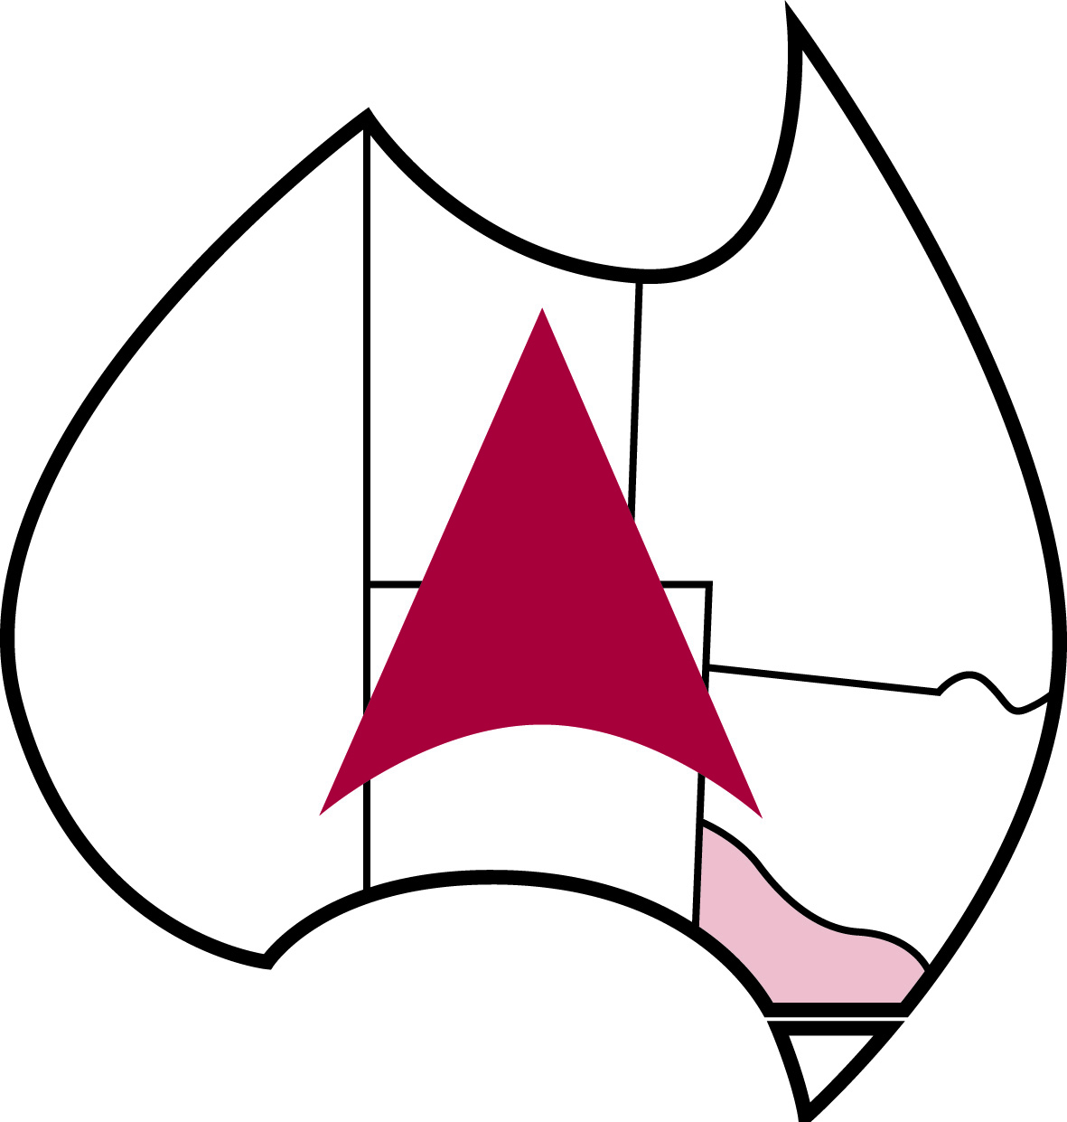

MUNICIPAL ENGINEERING FOUNDATION VICTORIA

CHAIRMAN’S ANNUAL REPORT – 2022

I am pleased to provide my annual report that highlights the activities and operations of the Municipal Engineering Foundation over the past 12 months.

We have continued our focus on providing opportunities to support and encourage the professional and personal development of public works engineering staff, to promote Local Government and the potential career opportunities and service outcomes within the sector.

It has been a successful year as we moved beyond the challenges of COVID and were able to normalize our operations.

During the past year we awarded the following:
- 2 scholarships to public works professionals, Edward Pocock from Baw Baw Shire Council (now Mornington Peninsula Shire Council) and Anthony Stratikopoulos Yarra Ranges Shire Council (now Boroondara City Council) to participate in the 2022 Overseas Study Tour to USA and Canada. This included a number of site visits to municipalities in California, North Carolina, Illinois and Toronto, as well as attending the APWA PWX Congress in Charlotte, North Carolina. These awards were deferred from 2020, to reflect the impact of COVID and the necessary restrictions on international travel.
- IPWEA Vic
  - Asset Management Foundations Course: Kimberley Harrison - Port Phillip City Council and Weinbren Fong - Whitehorse City Council
  - Project Management Foundations Course: Bob Xu – Knox City Council and Senura Kodikara - Strathbogie Shire Council
  - International Public Works Conference: Rick Kwasek – Stonnington City Council and Daniel Kelabora – Latrobe City Council
  - IPWEA Vic Public Works Conference: 5 Regional Council members, 6 student members and 4 young IPWEA members
  - Road Engineering Foundations Program: 4 City Council members
  - Traffic and Transport Foundations Program: 3 Regional members
  - Stormwater Management Foundations Program: 2 Regional members
- Municipal Works Australia
  - National Works and Engineering Annual Conference: Steve Gilmour – Golden Plains Shire Council, Bivish Ghimire – Moorabool Shire Council and Mohit Jain – Southern Grampians Shire Council
- Additional activities during the year included:
  - The participation and delivery of a webinar auspiced by Chicago APWA International Affairs Committee by 3 Victorian Public Works Engineers – Tony McGann, Lachlan Johnson and Ross Goyne. This opportunity allowed us to share Australian and Victorian practices and engage with our US colleagues.
  - Coordinating and supporting 3 representatives participating in the Chicago APWA Chapter and MEFVic joint study tour to attend the IPWEA International Public Works Conference in Adelaide and then undertake a study tour of Victorian Councils. We would like to acknowledge and thank the host Councils of Bass Coast Shire Council, Whitehorse City Council, Port Phillip City Council, Stonnington City Council and the North East Link Authority for providing the opportunity to share and engage with our international guests.
  - Preparation of a supplement to the History of the Foundation – published and available on the website.

We held our annual Awards Recognition Luncheon in August which provided the opportunity for over 80 guests to recognize our 2022 International Study tour awardees and listen to an engaging discussion with our guest speaker Mr Nick Foa in his then role as Head of Transport Services Department of Transport Victoria. I would also like to recognise the contribution of our corporate sponsor of the event UMS and thank them for their ongoing support.

The Trustees have met regularly and continued to maintain the focus on our strategic vision and objectives to support and develop Public Works Engineers through study tours, attendance at conferences and training programs. To that end we reviewed our Financial Strategic Plan in February 2022, and also undertook an extensive Strategic Planning Workshop which reviewed such matters as: Council Donations and support, 10-year financial Plan, Communications Strategy, Awards Program, Study Tour Presentations and reports, partnerships, succession planning and sector engagement. This workshop provided the catalyst for ongoing work and development of a Foundations action plan.

Another key action completed this year was the review and redevelopment of the MEFVic Website to ensure it is relevant, current and easily navigated to research past papers and matters of interest.

We continued to monitor our financial position to ensure we are able to continue delivering relevant awards and development opportunities for the sector. However, this year proved to be challenging and we ended up with a deficit notwithstanding prudent expenditure. Unfortunately like many other organisations we were impacted by low interest rates and lower than anticipated Council donations.

Our ongoing ability to deliver on our vision is clearly dependent upon the generous support of a number of Victorian Councils and I want to recognise and thank those Councils that have responded to our annual request for donations. Without their support we would not be able to achieve as much as we do.

During the year, Rob Mitchell retired as a Trustee after 18 years and I would like to formally place on record our thanks and recognise the invaluable contribution Rob made to the Foundation over all those years.

I also have pleasure in advising that Mark Varmalis has been reappointed as a Trustee of the Foundation for a further 5 years and look forward to Mark’s ongoing contribution to the success of the Foundation.

Additionally, I am pleased to congratulate one of our Trustees – Mr Steven White who was awarded the IPWEA (Vic) Public Works Leadership award

During 2023 the Foundation will provide a range of opportunities for the ongoing professional and personal development of public works engineers through opportunities such as:
- The provision of scholarships for public works engineers to undertake a study tour to the United States and Canada on an itinerary of up to three weeks incorporating attendance at the American Public Works Association Congress in San Diego, California. The awardees will study topics that are relevant and current for the industry. Applications for the study tour are currently advertised and will close 3 February 2023
- Attendance for public works engineers and students at relevant conferences and events and training programs.
- Continuing to develop new initiatives and opportunities that allow for the development and sharing of ideas and practices between the US and Australia. To quote one of our international colleagues – “we are striving to make the world a smaller place!”
- Ongoing support for IPWEA Vic initiatives and programs.
- The award of the 2023 MEFVic Award for Engineering Excellence (Cedric Tuxen Medal)

On behalf of the Trustees and the sector I would like to recognise and thank our Secretary Mr Merv Paton. Your professionalism, support and commitment to the Foundation is acknowledged and is greatly appreciated.

I would also like to personally extend my thanks to my fellow Trustees and Secretary for their support, contribution and passion, which will ensure the Foundation can continue to remain relevant and deliver valuable outcomes for the sector and communities we serve.

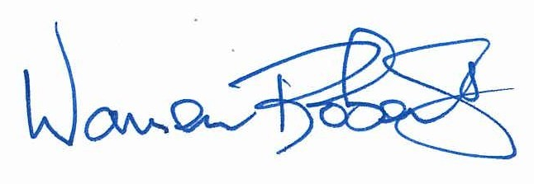

Warren Roberts
Chairman

